**DAY 2 PLANNING THE TECHNICAL FOUNDATION**

## **2. Key Workflows:**

### *****User Workflows*****

#### **Product Browsing**:

1. *User visits the website.*
2. *Frontend sends a GET request to /products API.*
3. *API fetches product data from Sanity CMS.*
4. *Data is displayed on the website for user interaction.*

#### **Placing an Order:**

1. *User adds items to cart.*
2. *User proceeds to checkout and completes payment via Payment Gateway.*
3. *Frontend sends a POST request to /orders with order details.*
4. *API stores order information in Sanity CMS.*
5. *Confirmation is displayed to the user.*

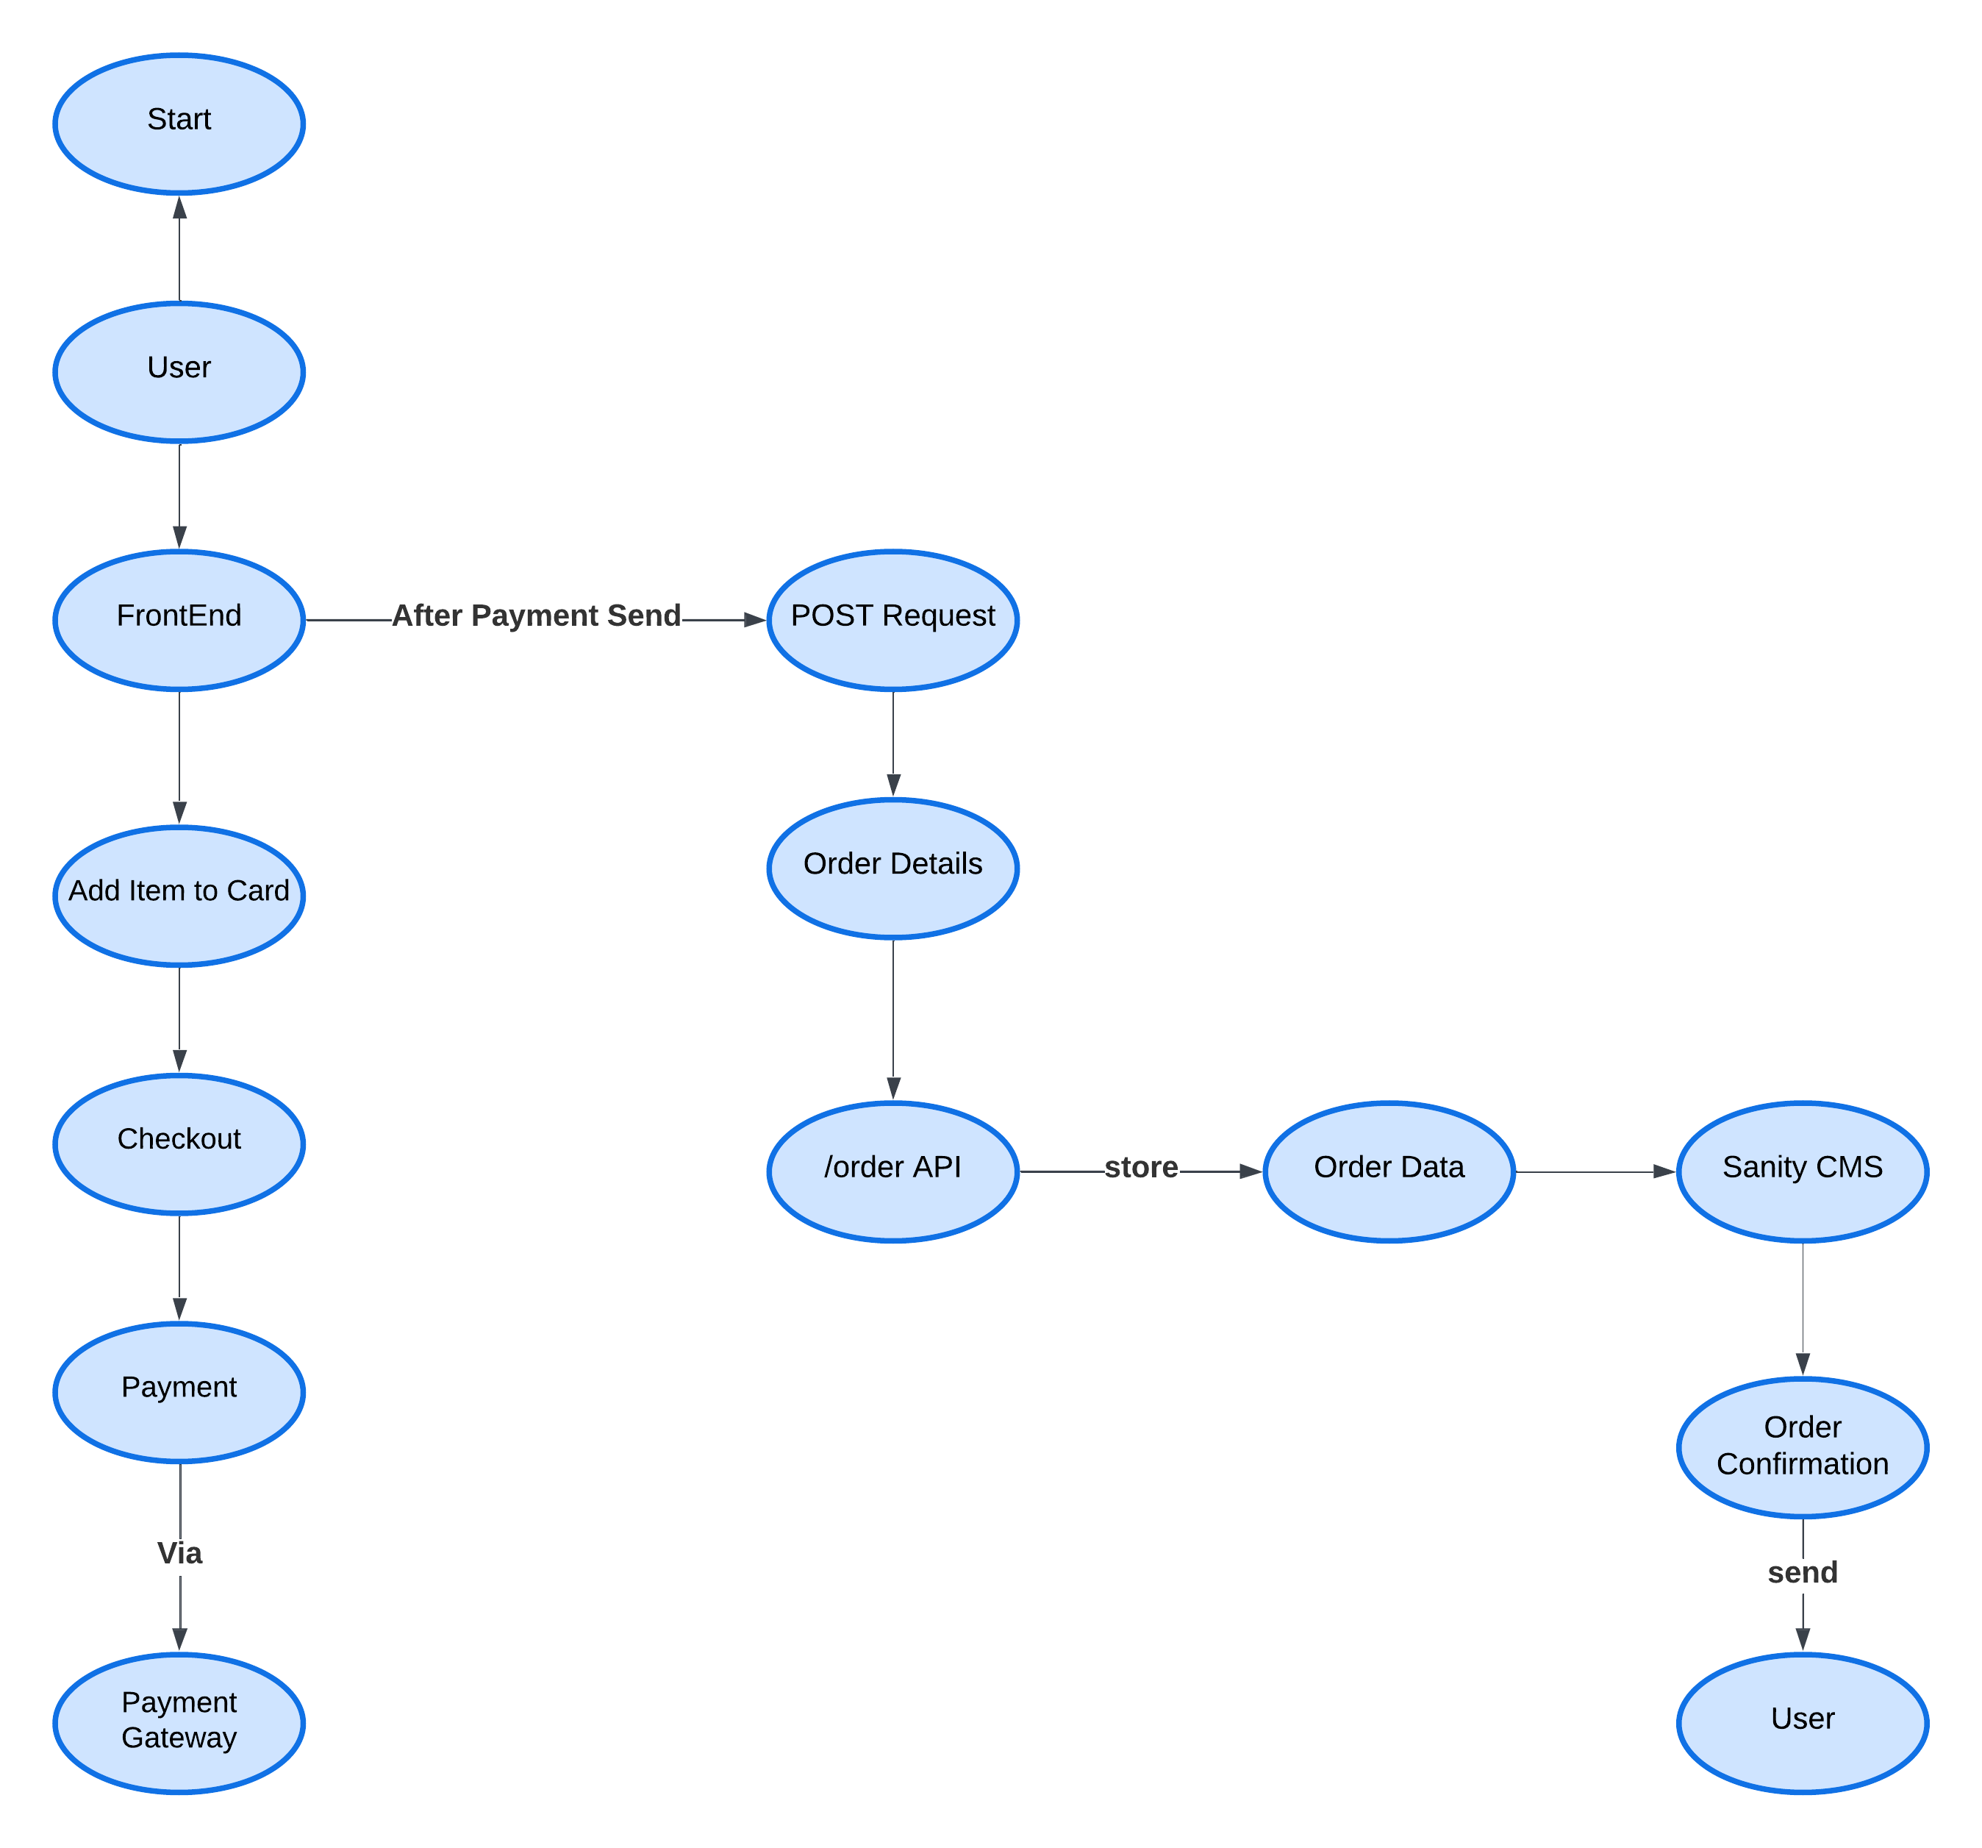

#### **Renting Furniture**:

1. *User selects a product and rental duration.*
2. *Frontend sends a POST request to /rental API.*
3. *API records rental details in Sanity CMS and deducts the deposit amount via Payment Gateway.*
4. *Rental confirmation is displayed to the user.*

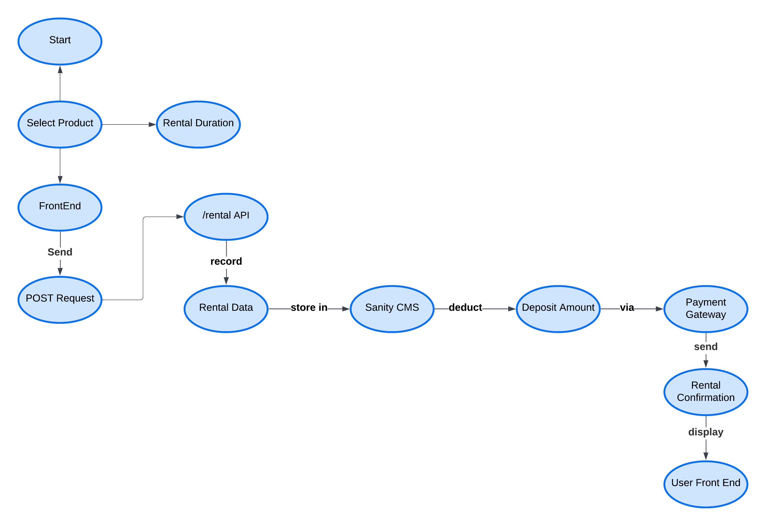

#### **Tracking Orders and Rentals**:

1. *User accesses their order/rental history.*
2. *Frontend sends GET requests to /orders or /rental.*
3. *API retrieves and displays order or rental data.*
4. *Shipment API is used to provide real-time updates for deliveries.*

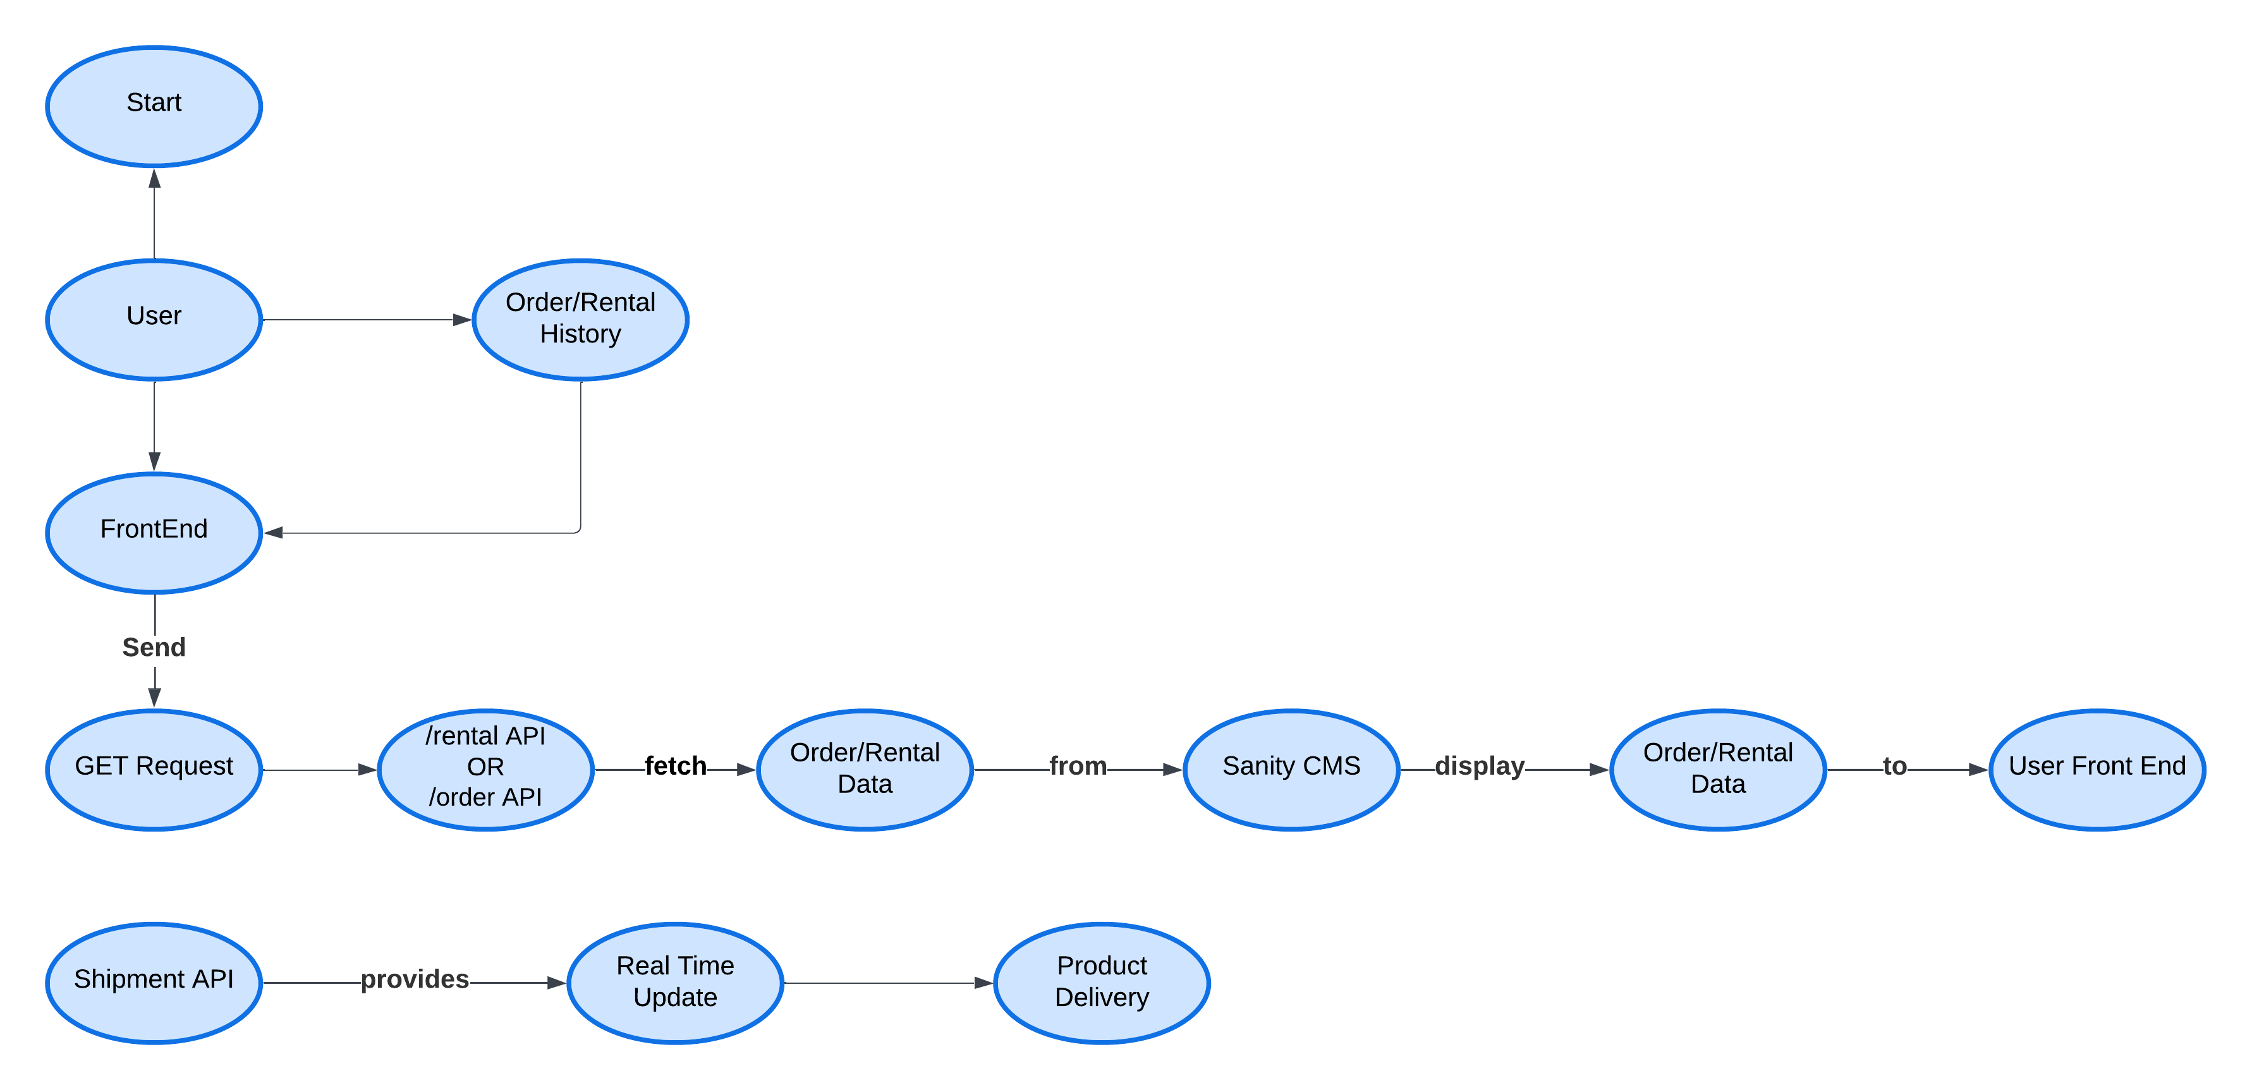

### ****Admin Workflows****

#### **Managing Products**:

1. *Admin logs into the admin panel.*
2. *Admin adds or updates product details.*
3. *Frontend sends POST/PUT requests to /products API.*
4. *API updates product data in Sanity CMS.*

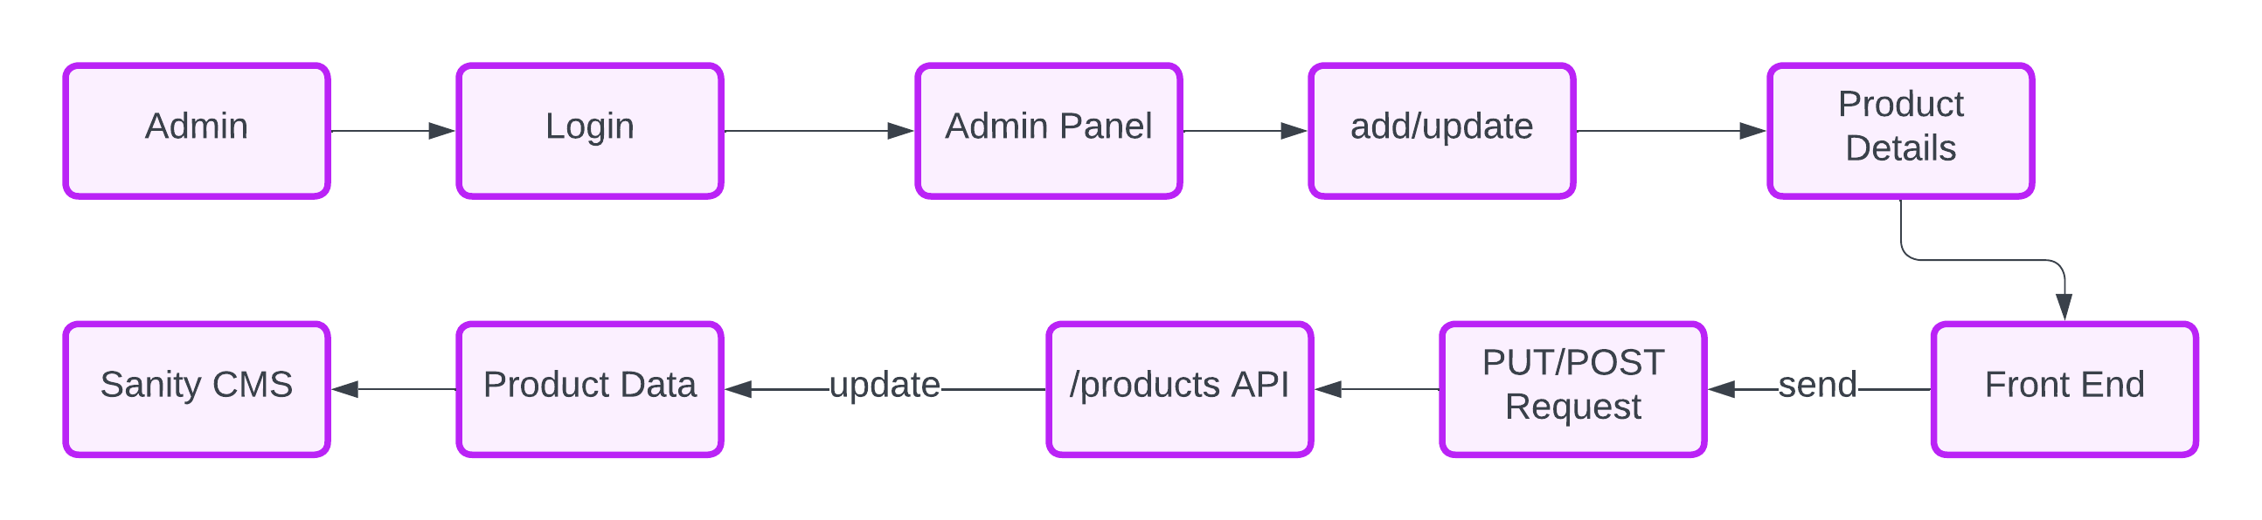

#### **Monitoring Orders and Rentals**:

1. *Admin views order or rental data.*
2. *Frontend sends GET requests to /orders or /rental.*
3. 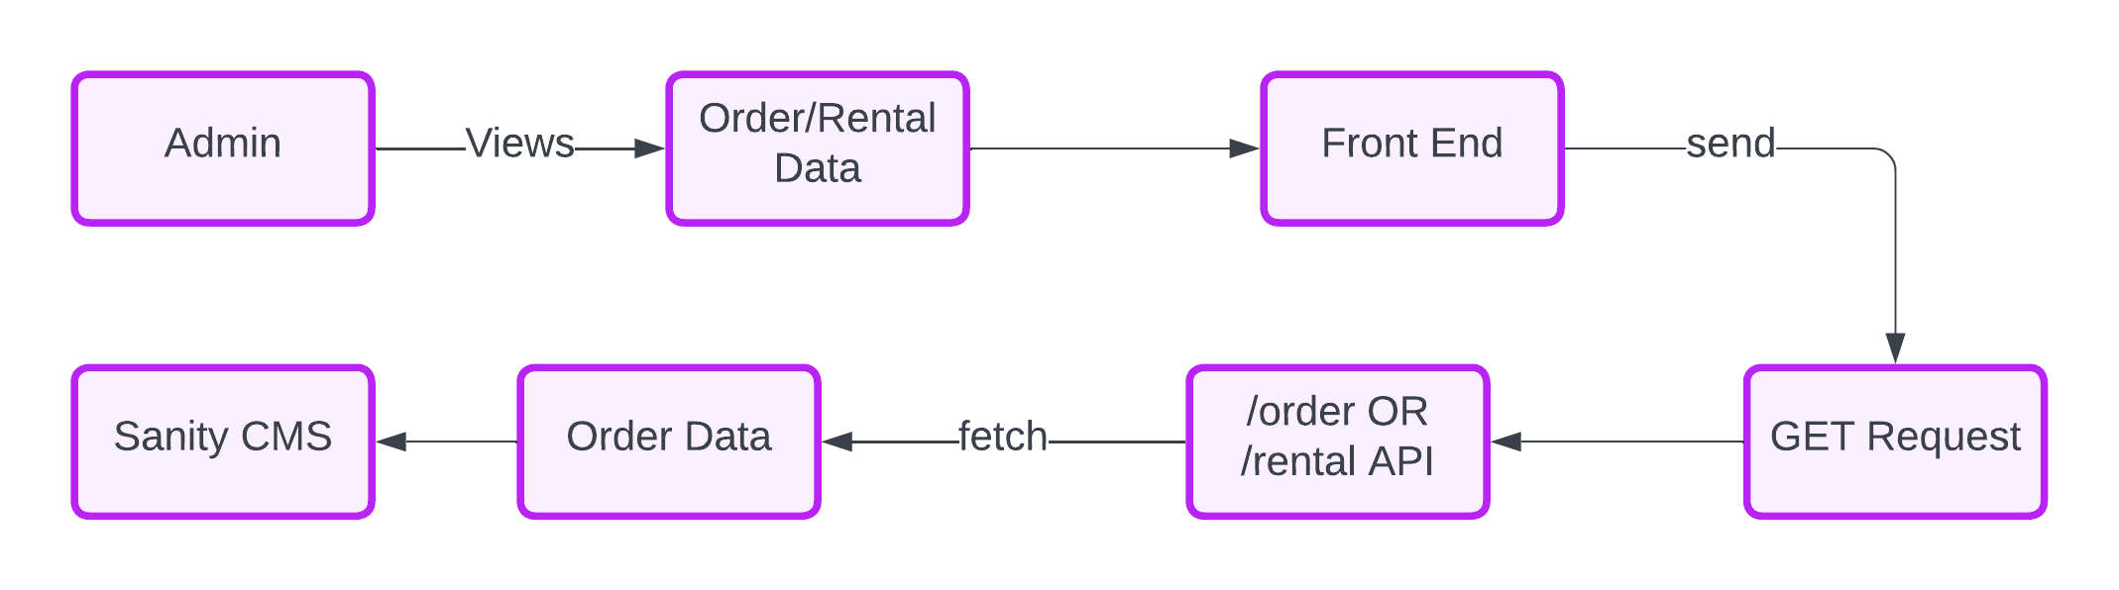*API retrieves data from Sanity CMS for admin action.*